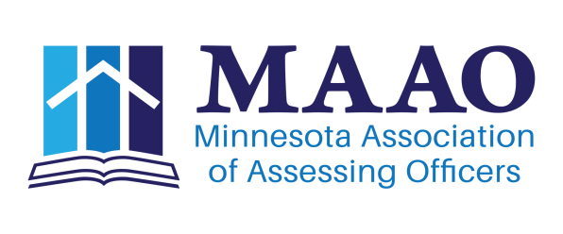
Information Systems Committee Report
August 21, 2017

- Number of Website updates
  - Regions that haven’t sent updates please do.
  - If you have sent updates and the web hasn’t been updated, please drop me a note.
- MAAO Inventory
  - 2017 Replacements
    - Jackie’s Surface Pro, Purchased Apple MacBook Air
    - Couple of External Hardrive’s (Reed & Matt)
      - Not Purchased
    - 2018 Replacements
      - 5 Machines, Lori, Penny, Reed, Matt & extra Education machine. (Matt’s Possession should go to Jackie???)
    - Inventory Update, need Jason’s info.
- Committee Chair Website Training Ongoing
  - August 28, City of Bloomington afternoon. Registration requested. MAAO Website.
- Jobs Board Update
  - Your Membership went live June 2017
  - Any Feedback???

Historic Job Postings
2011 – 34
2012 – 62
2013 – 80
2014 – 80
2015 – 89
2016 – 87
2017 YTD 38 postings (14 utilizing Your Membership)

Respectfully Submitted
Matt Gersemehl, Information Systems Chair

